CI EMP

* Step1:
  + Pick a male, enter 4’8” and 150lbs, then show rates
  + Edit to 4’7” and (properly) see error message (albeit, would prefer to show both height and weight in red, since it only appears that weight is ‘incorrect’, but…), and (properly) that male is removed from GBB table
  + Edit weight to something else (say, 151 lbs) and the male is still out of the table (properly, since he’s under-height) but the error message goes away so that there appears to be no problem.

*CI EMP via Custom Product  
NOTE: I think we should push this into next version and not troubleshoot this for now. I’m just documenting what I’ve found here so you can put it into tracking system.*

* *When enrolling a Custom verson of Group CI, the “replacement questions” are erroneously displayed (i.e., should be none, and they don’t appear on just enrolling the base Group CI).*
* *When GI criteria met, we’re not dropping the “ignore” SOH question properly.*

Enrolling

* Weird stuff on + Add Coverage with respect to enrolled children
  + If 1 child enrolled, it appears that upon Add Coverage that child is duplicated into child2. Try this: enroll EE, Spouse and 1 Child; return to “Add Coverage for that same record, and note now identical child in Child1 and Child2.
  + If 2 children enrolled, it appears to overwrite child2 with a duplicate of child1 (or maybe it’s overwriting child1 with dup of child2?).
  + If 3 children enrolled, it appears to drop Child1 and only display the former #2 and #3 as now #1 and #2 (thus showing only 2 children). Also, I noted that even though I waived-off the Add Coverage on this record, downloading the enrollment file showed that Child1 was indeed missing.
* On Add Coverage Step1, still need some navigation at bottom of page to return to census (perhaps a smaller “Cancel” button to left of “Previous” button? Similar to cancel next to Save on Edit census record  
   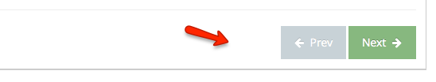
* Ad-Hoc Enroll not in Case Census:  
  is there a purpose for repeating the SSN below the input box as I type?  
  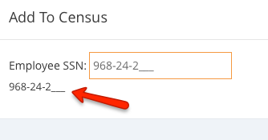
* Ad-Hoc Enroll (no case): selecting “I decline to enroll…” in Step1 gives “an error occurred communicating with server” browser error.

Case Setup

* Still need to change “Open Enrollment” to “Enrollment Period” with an “End Date”
* Census: need to allow (not require) fields for smoker/non-smoker, height & weight. What should default value/input look like? How about headers HEIGHT_IN, WEIGHT_LBS, and SMOKER_Y_N, allowing hopefully obvious inputs.

GI Product Setup

* Let’s set weight range to go from 50min to 350max on “Criteria setting”

Reports

* Still need to make “Timestamp” first column in enrollment download file

Other To-Do from/with Bill Davis (in no certain order)

* Provide replacement sample census download file
* Provide GroupCI template ID for Docusign per state
* Provide remaining state-specific GroupCI SOH text
* Connect Docusign templates, including pushing new data fields and SOH answer values into Docusign template-populating function
* Discuss/confirm migration of old site to new site with fresh DB; setup/confirm DB backup service in Heroku.